PROJECT DOCUMENTATION

Prepared by: ASHMITHAA P

Course: Data Analytics and Data Science

Batch: August – 2025

SALARY TRENDS ANALYSIS ACROSS

INDUSTRIES

1. INTRODUCTION
In the modern global workforce, salary structures play a critical role in shaping employee satisfaction, talent retention, and organizational competitiveness. With industries evolving rapidly and roles becoming more specialized, understanding how compensation varies across industries, education levels, experience, gender, and geography has become increasingly important. Organizations rely on data-driven insights to design fair and competitive salary structures, while professionals use such insights to make informed career decisions.
This project, titled “Salary Trends Analysis Across Industries”, aims to analyze a comprehensive salary survey dataset using a structured data analytics approach. The project integrates data cleaning, SQL-based querying, Excel-based analysis, and interactive dashboard creation to uncover meaningful salary trends and patterns. The final output is an intuitive dashboard and a detailed analytical report that clearly communicates insights derived from the data.

2. PROJECT OBJECTIVES
The primary objectives of this project are:
- To analyze salary trends across different industries and job roles
- To evaluate how education level influences salary and total compensation
- To compare salary and bonus distribution across genders
- To assess the relationship between years of professional experience and compensation
- To identify top-paying industries, job titles, cities, and countries
- To design an interactive Excel dashboard for effective visualization
- To demonstrate end-to-end data analytics skills using Excel and SQL
These objectives ensure that the project not only provides analytical insights but also aligns with real-world business and HR decision-making needs.

3. DATASET OVERVIEW
The dataset used in this project is a global salary survey dataset that captures detailed information about employees working across multiple industries and regions.

3.1 Dataset Attributes
The dataset includes the following key attributes:
- Demographic Information: Age Range, Gender
- Professional Information: Industry, Job Title, Job Title Clarification
- Compensation Details: Annual Salary, Additional Monetary Compensation (bonuses, commissions)
- Education Details: Highest Level of Education Completed
- Experience Metrics:
  - Years of Professional Experience Overall
  - Years of Professional Experience in Field
- Geographic Information: Country, State, City
- Currency Information: Currency type and custom currency field

3.2 Dataset Size
- Total number of employee records analyzed: 24,205
The diversity and size of the dataset enable a robust and comprehensive analysis of salary trends across industries and geographies.

4. DATA CLEANING AND PREPROCESSING
Data cleaning is a foundational step in any analytics project, as raw datasets often contain missing values, inconsistencies, and anomalies that can distort analysis results. In this project, extensive data preprocessing was carried out to ensure accuracy and reliability.

4.1 Handling Missing Values
- Numerical columns such as Annual Salary and Additional Monetary Compensation were checked for missing values
- Missing numerical values were either removed or handled based on analytical relevance
- Missing categorical values (Industry, Job Title, Gender) were replaced with suitable placeholders such as "Unknown"

4.2 Data Type Standardization
- Salary and compensation fields were converted into numeric formats
- Experience-related columns were standardized as integers
- Categorical columns were formatted consistently

4.3 Handling Inconsistent Values
- Job titles with spelling or capitalization variations were standardized
- Industry names were normalized to avoid duplication
- Country and city names were standardized to maintain geographic consistency

4.4 Outlier Detection and Treatment
- Extremely high or low salary values were identified
- Outliers were reviewed carefully to decide whether they represented valid executive-level salaries or data errors
- Appropriate filtering was applied to avoid misleading analysis

4.5 Final Cleaned Dataset
After completing the preprocessing steps, a clean and structured dataset was prepared and exported for MySQL integration.

5. MYSQL DATABASE INTEGRATION
To enable efficient querying and structured data management, the cleaned dataset was imported into a MySQL database.

5.1 Database Creation
- A new database was created using MySQL Workbench
- Appropriate data types were assigned to each column

5.2 Table Design
- A single table was created to store all salary-related information
- Primary keys and indexing were applied where necessary

5.3 Data Import
- The cleaned dataset was imported using MySQL import tools
- Data validation checks were performed to ensure accuracy
Using MySQL allowed efficient handling of large datasets and supported complex analytical queries.

6. SQL QUERY DEVELOPMENT
SQL was used extensively to extract meaningful insights required for analysis and dashboard creation.

6.1 Key SQL Queries Executed
- Average salary by industry and gender
- Total compensation by job title
- Salary distribution by education level (average, minimum, maximum)
- Employee count by industry and years of experience
- Median salary by age range and gender
- Highest-paying job titles in each country
- Average salary by city and industry
- Percentage of employees receiving bonuses by gender
- Total compensation by job title and experience
- Average salary by industry, gender, and education level
Each query was optimized and its results were exported for Excel-based analysis.

7. EXCEL ANALYSIS AND PIVOT TABLES
The SQL query outputs were imported into Excel as individual sheets for further analysis.

7.1 Pivot Table Creation
- Pivot tables were created to summarize salary metrics
- Aggregations such as average, sum, count, and median were applied
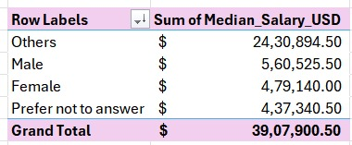

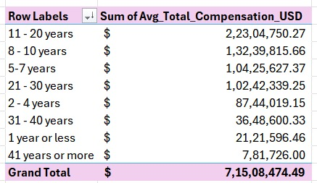

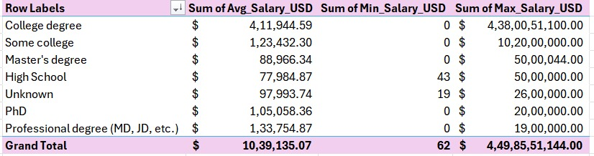

7.2 Pivot Charts
- Bar charts, column charts, pie charts, and line charts were used
- Charts were designed to clearly represent salary trends and comparisons
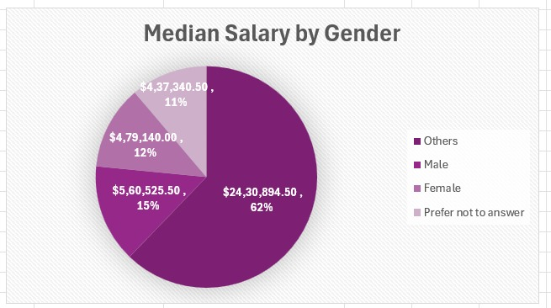
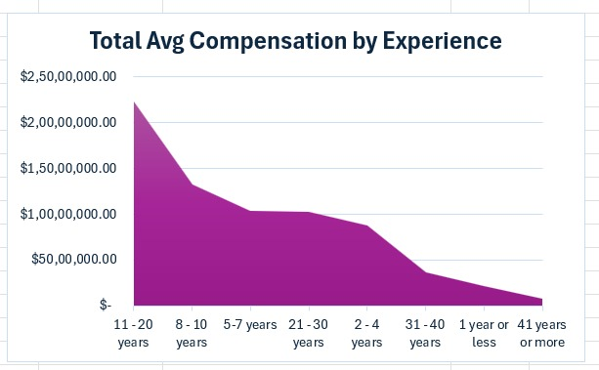
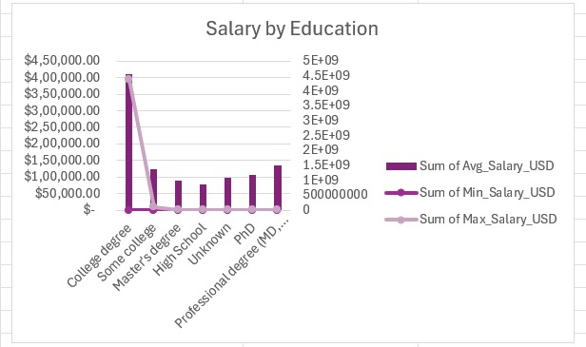

  - Interactivity
- Slicers were added for Gender, Age Range, Industry, and Experience.
- Interactive filters allowed dynamic analysis.
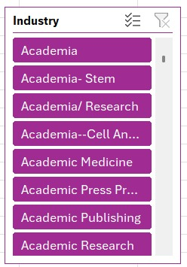
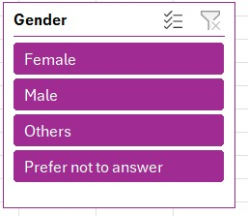

8. DASHBOARD DESIGN AND COMPONENTS
The final Excel dashboard provides a consolidated and interactive view of all insights.
8.1 Key Performance Indicators (KPIs)
- Total Employee Count: 24,205
- Total Average Salary
- Maximum Salary by Education Level
- Total Average Compensation

8.2 Visual Components
- Top and least paying industries
- Salary comparison by gender and education
- Bonus percentage by gender
- Median salary distribution
- Highest-paying job titles and countries
- Experience-based compensation trends

8.3 Dashboard Benefits
- Easy-to-understand visual layout
- Interactive exploration of salary data
- Quick decision-making support

9. KEY INSIGHTS AND FINDINGS
- Industries such as technology and finance show higher average salaries
- Education level has a strong positive correlation with compensation
- Years of experience significantly impact salary growth
- Gender-based salary differences are visible across industries
- Certain cities consistently offer higher compensation
- Senior and specialized job roles command premium salaries
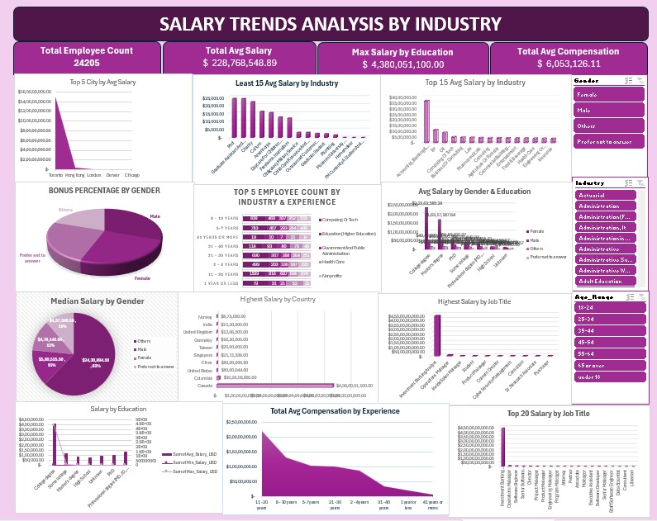

10. BUSINESS USE CASES
- Human Resources: Salary benchmarking and pay gap analysis
- Management: Workforce planning and compensation strategy
- Job Seekers: Career and salary expectation planning
- Organizations: Improving transparency and fairness in pay structures

11. LIMITATIONS OF THE STUDY
- Salary data is self-reported and may contain bias
- Currency conversion assumptions may affect precision
- Industry classifications may vary across regions

12. CONCLUSION
This project successfully demonstrates a complete data analytics workflow, from raw data preprocessing to advanced SQL querying and interactive dashboard creation. By leveraging Excel and MySQL, the analysis uncovers valuable insights into salary trends across industries, education levels, experience, and geography. The final dashboard and documentation provide a strong foundation for data-driven compensation analysis and strategic decision-making.

13. TOOLS AND TECHNOLOGIES USED
- Microsoft Excel
- MySQL
- SQL
- Pivot Tables and Charts

14. OVERALL SUMMARY
The Salary Trends Analysis Across Industries project highlights how structured data analysis and visualization can transform raw salary data into meaningful business insights. The project reflects strong analytical thinking, technical proficiency, and practical application of data analytics concepts.

